Remove Punctuation
Python.file:

Screenshot:
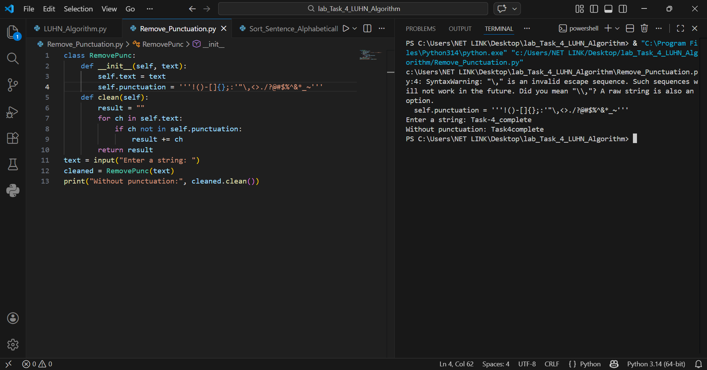

Main Components
• Class: RemovePunc
• Attribute:
- self.text(stores input text)
- self.punctuation(stores punctuation characters)
• Method: clean()removes punctuation
• Loop: Iterates through each character
• Logic: Filters out punctuation symbols

How the Program Works

1. Start
• The program asks the user to enter a string.
• An object of the RemovePunc class is created.
• The input text is stored in self.text.

2. Define Punctuation
• A string of punctuation characters is stored in self.punctuation.
• This includes symbols like:
! ( ) [ ] { } ; : ' " , . ? @ # etc.

3. Loop Through Characters
• The program loops through each character in the input text.
• Each character is checked one by one.

4. Remove Punctuation
• If a character is NOT in the punctuation list:
→ It is added to the result string.
• If it IS punctuation:
→ It is skipped.

5. Build Clean String
• A new string is created without punctuation.
• This string is stored in the variable result.

